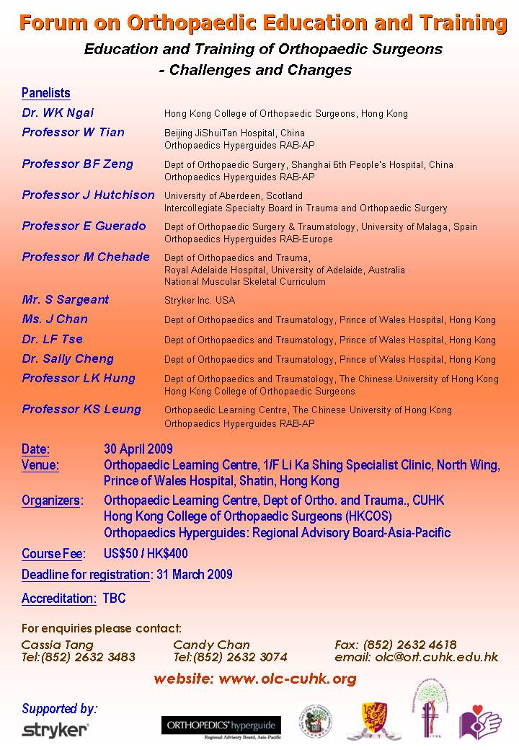
Application Form
Name: ___________________________ ________________________
(First Name) (Last Name)
Hospital: ______________________________________________________________________
Correspondence address: ________________________________________________________
________________________________________________________
________________________________________________________
Phone: ________________ Fax: _________________ E-mail: _________________________

Parking
There are only limited free parking spaces available for participants, our parking reservation service are on first-come first-served basis. Please provide your car registration number to us and we will confirm with you as soon as possible.
Car registration no. ____________________________

Recommended Hotel-Accommodation
The organizer recommends following hotels in the nearby districts of the forum venue.

Regal Riverside Hotel: Address: 34-36, Tai Chung Kiu Road, Shatin, N.T., Hong Kong Tel: (852) 2649 7878 Fax: (852) 2637 4748
Royal Park Hotel: Address: 8 Pak Hok Ting Street, Shatin, Hong Kong Tel: (852) 2601 2111 Fax: (852) 2601 3666

Payment
Please mail your application together with a cheque payable to “The Chinese University of Hong Kong” to Orthopaedic Learning Centre,1/F Li Ka Shing Specialist Clinic, North Wing, Prince of Wales Hospital, Shatin, HK if you are using the cheque payment: Please send to us by fax at (852) 2632 4618 if you are using credit card payment.

Please complete Credit Card Payment Authorisation below if you are using credit card payment

Credit Card Payment of Registration Fee
I hereby authorize the Chinese University of Hong Kong to debit the following credit card in the total amount indicated below for payment of the registration fee for the above-mentioned person(s).

Paying Cardmember Name : _____________________________ (As shown on card.)

Paying Card Number: ___________________________________ Expiry Date : ___________________
❑ VISA  MasterCard

Total Amount to be Debited: US$50 / HK$400

Paying Cardmember Contact : Tel.: ( ) ___________________ Fax: ( ) ___________________

Authorized Signature : __________________________________ Date :_________________________ (As shown on card.)

